Lab 5
Q1
Command
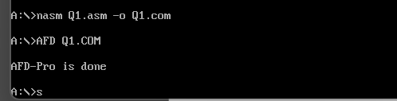
Code
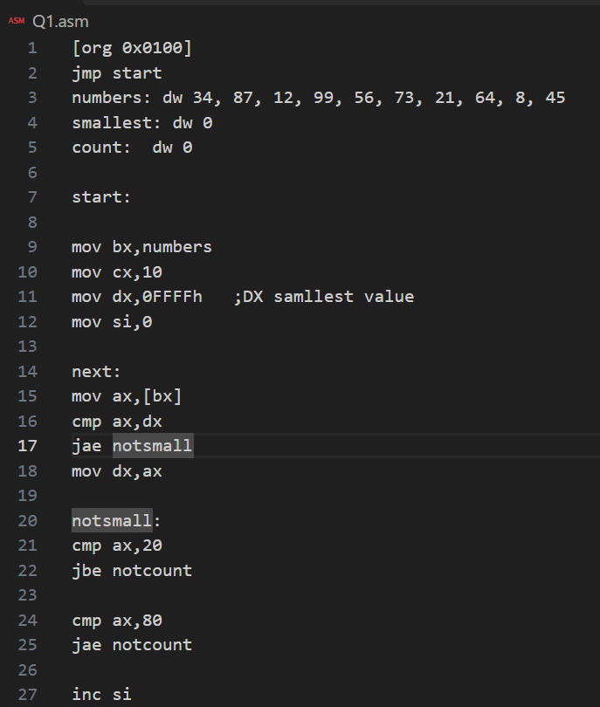
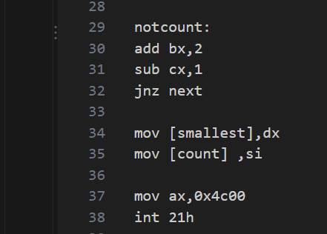
Screenshot
- DX(0008)
- SI(0006)
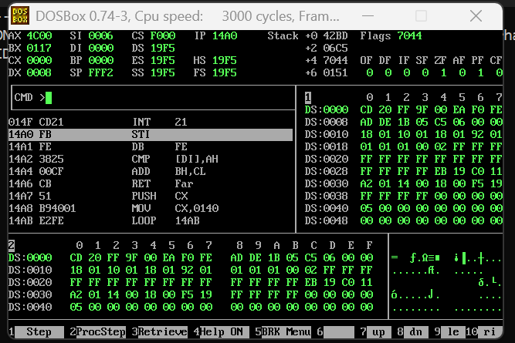

Question 2
Command
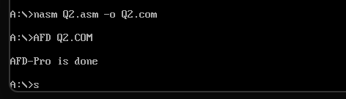
Code
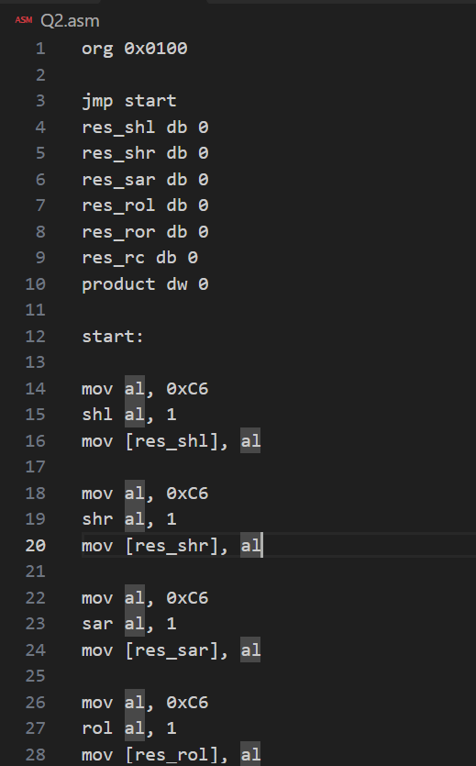
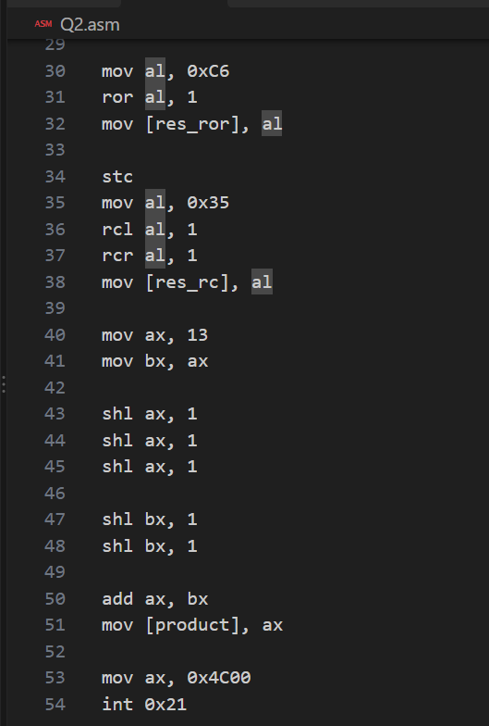
Screenshot
SHL
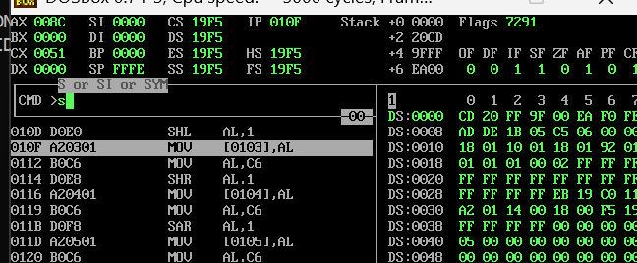
SHR
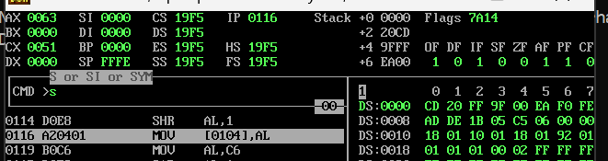
SAR
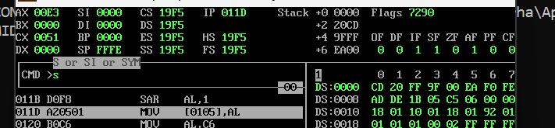
ROL
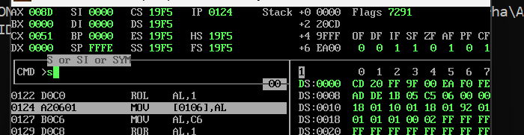
ROR
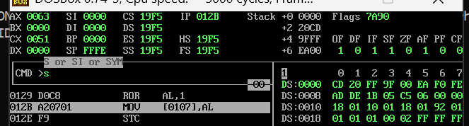
RCL
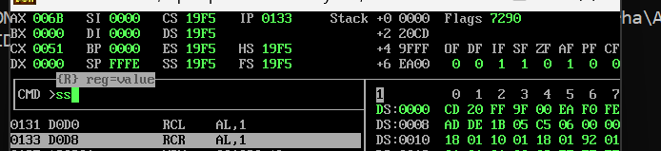
RCR
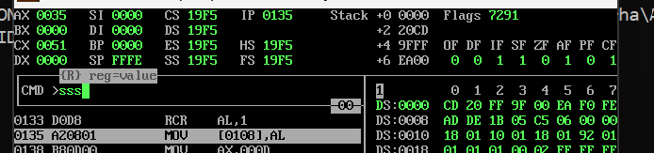

Short note:
SAR keeps the sign bit (MSB), while SHR fills the MSB with 0, so C6h gives different results. RCL and RCR are opposite rotations through the Carry Flag, so performing them one after another restores the original AL value.
Question 3
Command
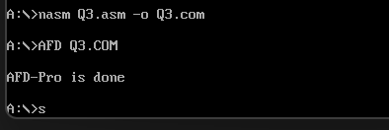
Code
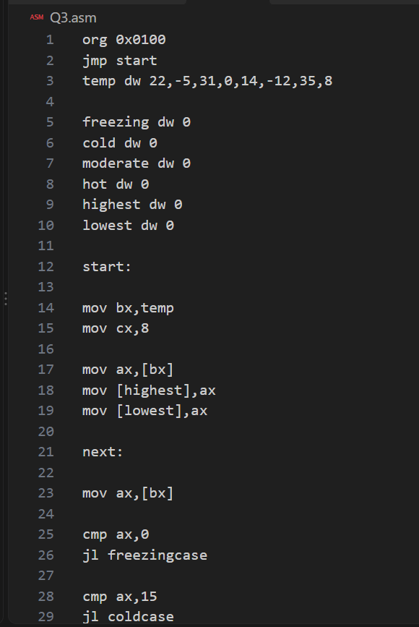
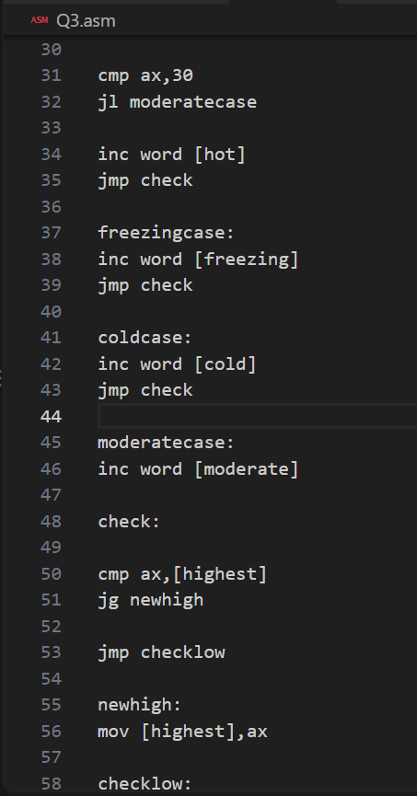
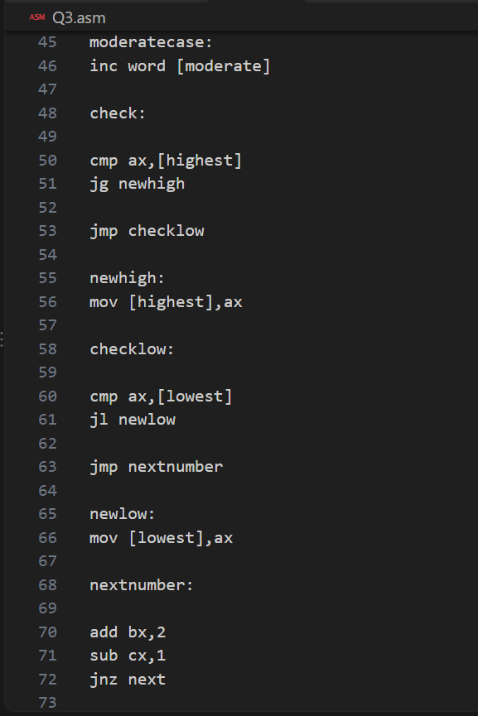
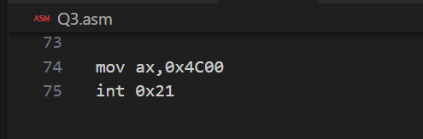
Screenshot


